Call for Papers

International Scientific-Training Conference
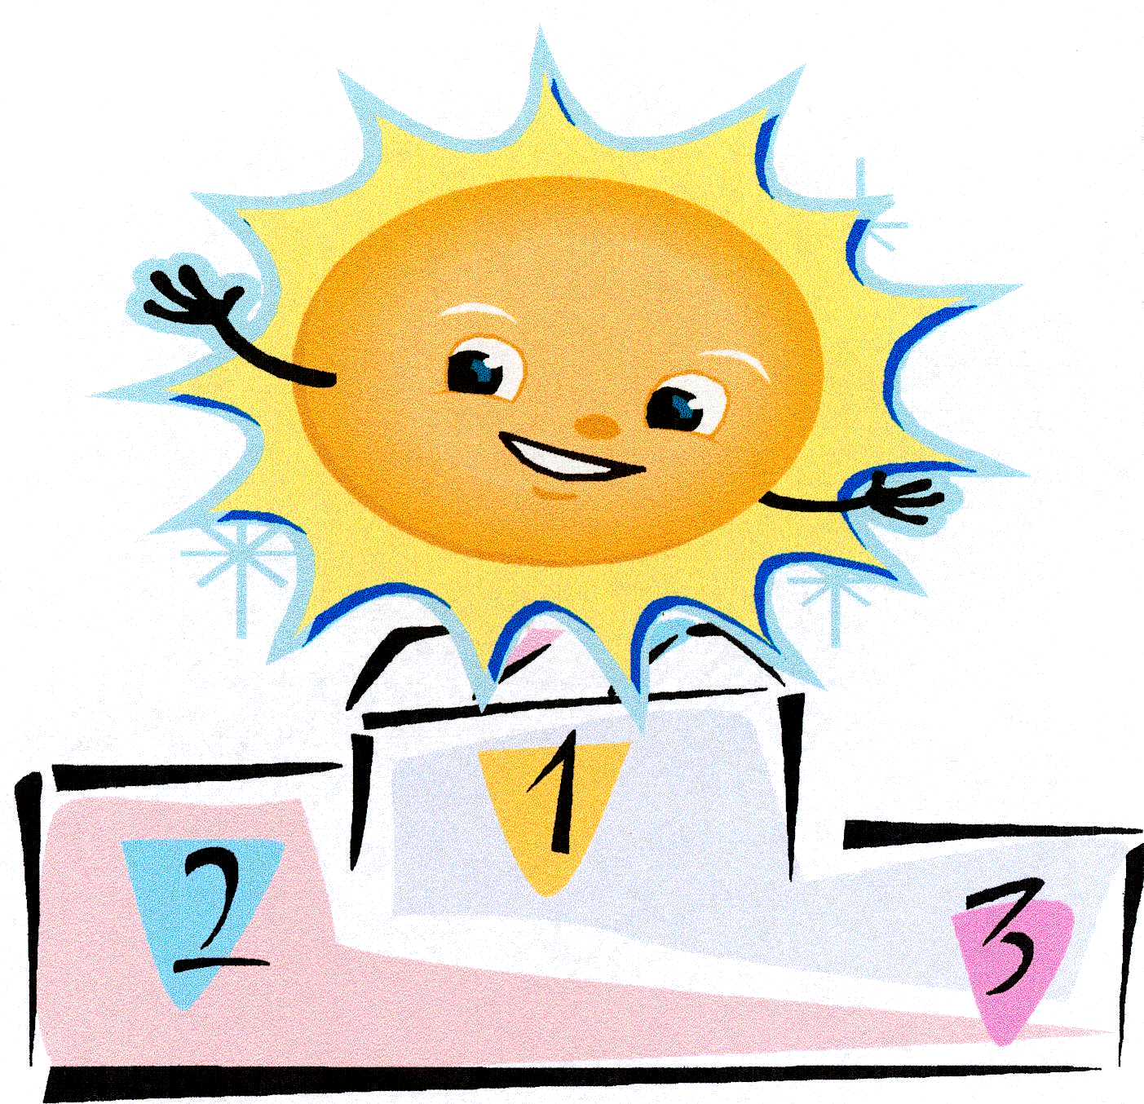

Wellness and success
Dobrostan i powodzenie

Lublin, 5 – 7 June 2009

Office: skr. poczt. 275 ul. Jaczewskiego 8, 20-954 Lublin Poland,

phone: (081) 740-80-75; 0 508 055 616; 0 516 169 227; 0 503 513 454
e-mail: wanda.lewicka@epf.pl. or: wanda.lewicka@um.lublin.pl.

The Conference is organized by:
- Faculty of Nursing and Health Sciences, Medical University of Lublin
- Chair and Department of Neurological Nursing Medical University of Lublin
- John Paul II State Vocational College of Higher Education in Biala Podlaska
- Maria Curie Skłodowska University In Lublin, Department of Pedeutology and Health Care Education
- National Wellness Institute University of Wisconsin Stevens Point, USA

The goal of the Conference is to create an interdisciplinary forum for presenting to date scientific accomplishments in the area of health promotion and establishing new frontiers in research.

The Conference is held during the celebration of the 40-year anniversary of academic education of nurses and midwives at the Medical University in Lublin and this session marks the anniversary.
- Fortieth anniversary of higher education of nurses and midwives at the Medical University in Lublin
Suggested topics for proceedings:
- Impact of a lifestyle on wellness and prosperity
- Wellness and prosperity in sickness and disability
- Cultural behaviors conditioning wellness
- Education vs. wellness
- Wellness and support in good health and sickness
- Wellness and prosperity in different phases of life
- Wellness and success in sport
Conference attendance submission including scholarly work and a conference payment needs to be sent in by 28th February 2009. Cost of attendance 900,- zł includes conference materials, accommodation for 2 nights, welcoming meeting, meals for two days, a festive dinner, and a monograph with printed articles.
The received scholarly materials will be printed in monographs with a separate selected ISBN number.
First author listed on the sent-in article is to submit a conference payment. The conference payment covers the expense of printing one paper, it is possible to print multiple papers for an additional 250,-zł per paper. Submitting the conference payment is required for paper to print.
Account name: Kredyt Bank S.A. O/Lublin 1515001520-1215200064360000 NeuroCentrum ul. Hirszfelda 3/9, 20-092 Lublin NIP 7120062846.
Every article will be a chapter in a monograph. A chapter in a monograph is understood to be a scholarly compilation of minimum 20000 characters including spaces according to included scoring (Ordinance of Minister of Science and Higher Education dated 17th October 2007 regarding criteria and process of granting and reviewing financial resources for statute activities (Dz. U. Nr 205, poz. 1489).

Publication scoring
in Polish | in English
3 points | 7 points

The article needs to contain the following data in stated order: name and location of place of work in Polish and English language, full first and last name of author(s), title of the article in English and Polish.
The paper needs to be separated into the following sections:
- short introduction (a summary of essential terms and goal of research),
- materials (characterization of research materials),
- method (a succinct presentation of applied method and research techniques),
- results (text. tables, illustrations and graphs of research results – exclusively in Microsoft Word editor, using statistical methods for credibility of conclusions is recommended),
- summary (own results in confrontation to experiences of other researchers),
- conclusions (succinct generalizations resulting from research),
- list of works cited in alphabetical order numbered (up to 10 items), each item needs to include in order stated: last name of the author(s) and first letter of first names, title of the work, publisher (or periodical) year, pages. In the case of three or more authors – only the first author and abbreviation at all., for example:
- Bohnsack E., Jackson A. (red.): Poznaj swoją osobowość. Wyd. „DEBIT”, Bielsko-Biała 1996.
- Cloud H., Townsend J.: Sztuka mówienia „nie”. Świat Książki, Warszawa 1997.
- Płotka A.: Zdrowy styl życia psychicznego. Wyd. NeuroCentrum, Lublin 2003.

- abstract in English and Polish including the title of work, first and last name of authors.

The work needs to be submitted by e-mail to: wanda.lewicka@epf.pl or: wanda.lewicka@um.lublin.pl. Electronic version needs to be prepared with Microsoft Word, text needs to be written with Times New Roman (CE) font, size 10pt with 1,0 spacing between lines, margins: top 3,5 cm; bottom 4,5 cm; left 3,9 cm; right 4,0 cm, heading – 1,25 cm, footer 5,5 cm. Unacceptable are any text effects (bold and italics). The paragraphs need to be signified by unambiguous indents (using the Tab key). Digits used at the beginning of each sentence need to be spelled out. Punctuation (period, comma, and parenthesis) need to be placed immediately following a word. Tables and drawings (only Microsoft Word editor) cannot exceed article’s margin.
Table numbers are to be marked with roman numerals, and table captions placed above a table – for example Tab. I. Researched population, however a drawing, pictures, graphs are marked with an Arabic literal and caption is placed below the graph/drawing/picture. References to the list of works cited inside text body need to be written in square brackets, e.g. [2, 6, 9]. Not complying with above methods of article writing will result in returning work to the author.
All materials submitted for print are subject to review. The Editorial Board reserves the right to language, visual, and text layout corrections.
Authors do not receive honorarium for submitted work.
Conference Location: Recreational Park at Krasne Lake, Łęczna -Włodawa Lakeland.
Steering Committee

