The Wellness Institute coaching & training
Ewa Stelmasiak
Wellness coaching as an integral component
of the evolutionary vision for medicine
Wellness coaching jako integralna część ewolucyjnej wizji medycyny
Is a world without disease at all possible? What would need to happen in order for it to become a realistic objective for all of humanity? According to wellness pioneer John W. Travis “diseases and symptoms are (...) the body-mind-spirit’s attempt to solve a problem – they are a message from the subconscious to the conscious” [16, p. xvii]. How ready are we to read this message? How ready are we to keep our being in a state of balance, so that health problems don’t even emerge? In order to answer these questions, let us at first define health.

About health and disease
The Iceberg Model of Health and Disease created by the same author presents the state of health as a tip of an iceberg.
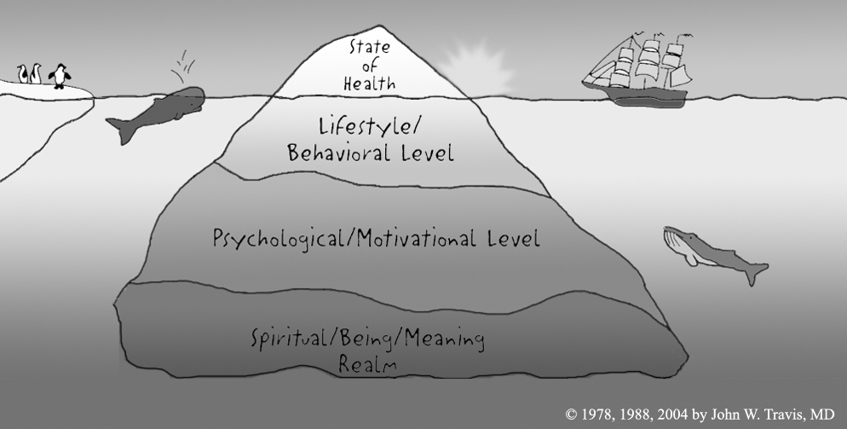

Fig. 1 The Iceberg Model of Health and Disease created by John W. Travis

What can be observed on the surface are the symptoms of illness, but most of its reasons are hidden under water. These may include reasons from the lifestyle/behavioral level, the culture/psychological/motivational level and the spiritual/being/meaning realm, consecutively. The first stands for eating, exercising, relaxing and letting go of stress, the second - for cultural norms that influence us and for our psychological well-being, whereas the third is related – among others - to our unconscious mind, the meaning of our life and our place in the universe. Since all these layers impact our level of health, in order to understand the causes of illness or health, it is necessary to also look below the surface of water [16, pp. xx-xxi]. Together with the concept of body-mind-spirit relative to wellness first introduced by Halbert L. Dunn in 1961 [7], this model lays the foundation for a holistic approach to health. Similarly, the definition of health created in 1948 by the World Health Organization states that it is “a state of complete physical, mental and social well-being, not merely the absence of disease or infirmity” [as cited in 1, p. 31].

Health and traditional western medicine
Despite this fact “mainstream thinking in Western medicine has traditionally considered the state of personal health (...) as independent of deeper levels and acted as if this were true” [15, p. xxii]. “Conventional healthcare tends to perceive health in a linear way” writes Laurel Alexander and names the following stages in this linearity: “Let’s identify the problem through tests. Here are the science-based solutions (pharmaceutical, manipulative or surgical) which you take or we do. We evaluate the impact of the solution on the problem.” [1, p. 32]. This medical mindset clearly stands in opposition to the above mentioned Iceberg Model of Health and Disease since it fails to take into account the underwater levels of being. Metaphorically said, we live in a world governed by the Pill Fairy. Doctors – as her attendants, pharmacists – as her special agents prescribe magical pills for disease and their magic is called medicine [16, p. 11]. As noted by Alexander “it is tempting for most people to take the quickest route even it may not be the best route for mind and body” [1, p. 33] since quick fixes correspond to the fast pace of life that we experience in the contemporary world. An enormous and lucrative “sickness industry” has built around the current need for quick solutions. As observed by Pilzer “people become [its] customers only when they are stricken by and react to a specific condition or ailment. No one really wants to be a customer” of this reactive business whose “products or services seek to either treat the symptoms of a disease or eliminate the disease” [12, pp. 4-5].

Complementary medicine
Complementary and alternative medicine “has been around for centuries and has gained popularity as a healthcare option” [1, p. 17]. The National Center for Complementary and Alternative Medicine defines it as “a group of diverse medical and healthcare systems, practices, and products that are not currently part of conventional medicine [2010, as cited in 1, p. 17]. The center classifies complementary and alternative therapies into five major groups, some of which overlap: whole medical systems (e.g. homeopathy, osteopathy, traditional Chinese medicine, naturopathic medicine), mind-body interventions (e.g. aromatherapy, hatha yoga, meditation, visualization or journaling), biologically based therapies which use natural substances (e.g. fasting, diet, herbal therapy), manipulative and body-based methods (e.g. acupressure, massage therapy, reflex point therapy) and energy therapies (e.g. Reiki, shiatsu, magnet therapy, medical qigong). For lack of scientific proof, this medicine has so often been rejected in its totality by western, traditional medicine. The disconnection between body and mind dates back to the 17th century, when French physicist, mathematician and philosopher Rene Descartes “differentiated between physical and mental substance” laying the foundation for mind-body dualism [5, p. 175]. Thanks to the work of Antonio Damasio first published in 1994 [6] it has become clear that humanity had been misled by this erroneous worldview for so many centuries. Also medicine has been under the influence of reductionist scientific materialism [16, p. 14] even though it is said to have adopted a science-based perspective as a result of scientific discoveries from the late 19th and early 20th centuries. During that time scientists who became international heroes put an ultimate end to such major diseases as tuberculosis, typhus or polio which had been the scourge of humankind. “Emboldened by this success, and partly to distinguish themselves from charlatans who were practicing magic more than medicine, Western medical science began arrogantly rejecting age-old treatments and cures whose function could not be scientifically explained by the then-current level of technology” [12, p. 37]. This phenomenon reflects the rational era in the evolution of humankind which remains so true for western medicine until today.

The Illness-Wellness Paradigm
Some major problems with this kind of approach may be curing symptoms without taking into account their causes such as lifestyle, mental states or the role of spiritual meaning, and reinforcing therefore a situation when the roots of suffering remain unexplored, which may in turn lead to symptoms turning into disability or even pre-mature death. The model created by John W. Travis & Regina S. Ryan entitled The Illness/Wellness Continuum first published in 1972 illustrates this difference between the wellness and the treatment paradigms particularly well.
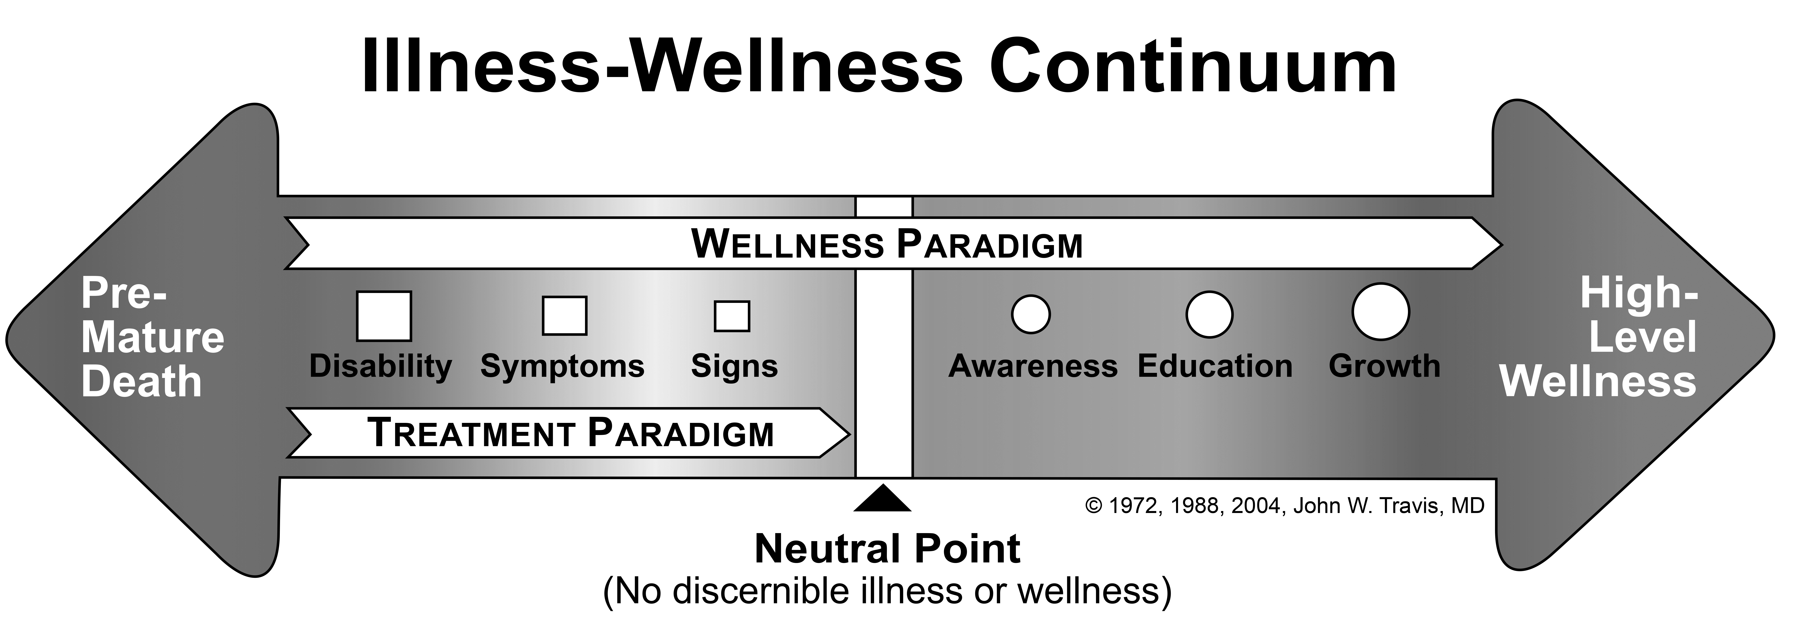

Fig. 2 The Illness/Wellness Continuum developed by John W. Travis
The model shows that “there are actually many degrees of wellness, just as there are many degrees of illness” [16, pp. xviii-xix]. These levels include signs, symptoms and disability leading to pre-mature death on the one hand and awareness, education and growth leading to high-level wellness on the other. In between them there is the neutral point with no discernable illness or wellness. “The treatment paradigm (...) can bring you up to the neutral point, where the symptoms of disease have been alleviated. The wellness paradigm, which can be utilized at any point on the continuum, helps you move toward higher levels of wellness. The wellness paradigm (...) is not meant to replace the treatment paradigm (...), but to work in harmony with it.” [16, p. xviii].

The future of medicine
What is therefore the future of medicine in that perspective ? Scientists use names like integral [18, p. 91], integrative [15, p. 395] or integrated medicine. The British Society of Integrated Medicine defines it as “an approach to health and healing that provides patients with individually tailored health and well-being programs which are designed to address the barriers to healing and provide the patient with the knowledge, skills and support to take better care of their physical, emotional psychological and spiritual health” [2008, as cited in 1, p. 30]. The American philosopher Ken Wilber puts medicine in the context of his integral theory. “Orthodox or conventional medicine (…) deals mostly with the physical organism using physical interventions: surgery, drugs, medication, and behavioral modification (…) [since it] believes essentially in the physical causes of physical illness” [19, p. 92]. His view of integral medicine is much broader, should be viewed through the prism of the Four Quadrants of Integral Medicine [19, p. 95] and includes among others emotional, cultural and social components in addition to the physical reality of symptoms (see Fig. 3).

Alternative care | Orthodox Medicine
Emotions | Surgery
Attitudes | Medication
Imagery | Behavioral modification
Visualization
I | IT
WE | ITS
Cultural Views | Social System
Group values | Economic factors
Cultural judgements | Insurance
Meaning of an illness | Healthcare policies
Support groups | Social delivery system

Fig. 3 Four Quadrants of Integral Medicine authored by Ken Wilber

Snyderman and Weil claim in turn that integrative medicine includes both conventional and alternative medicine and it “calls for restoration of the focus of medicine on health and healing and emphasizes the centrality of the patient-physician relationship” [15, p.396]. Similarly, Wilber emphasizes the importance of communication between doctor and patient and places it at the heart of his Lower-Left Quandrant group of intersubjective factors impacting physical illness and cure [18, p. 94].

The doctor-patient relationship
What are therefore some of the characteristics of the relationship between doctor and patient in Western medicine? According to Michael Arloski some of the current issues for doctors are lack of patient compliance with both pharmaceutical prescriptions and behavioral directions for lifestyle improvement causing considerable costs for healthcare systems. The author explains: “Just telling people what to do doesn’t work well. The inherent authority of medical personnel just doesn’t carry the same weight as it used to. (…) Culture, lack of money, time limitations, access to conflicting information on the internet, all play a role that is not addressed in the prescribe and treat system” [3, p. 38]. The issue of patients giving themselves to external experts who are supposed to fix them and make their health problems magically disappear has been addressed in 1977 by behavioral medicine. In addition to recognizing that “our thought patterns and emotions may play a significant role in health and disease” [9, p. 196], it emphasizes the need for adding a collaborative component to the relationship between doctor and patient. Behavioral medicine shifts the balance of responsibility for patients’ well-being “away from an exclusive dependency on their doctors (…) closer to their own efforts” [9, p. 197] thus calling for creating participatory and collaborative partnerships between patients and doctors where each of them has “a vital area of expertise, and both areas are important to the healing process” [9, p. 188]. How responsibility is being held today in the relationship between doctor and patient has yet been so well described by John Kabat-Zinn: “Too often scientific and technological sophistication of the traditional medical approach to disease leads in practice to an impersonal approach to the patient, as if medicine’s knowledge [was] (…) so powerful that the patient’s understanding, cooperation, and collaboration in treatment [were] (…) of minor value” [9, p. 187]. Despite the fact that complementary medicine may be using other than science-based methods, so many times the relationship between healer and patient remains based on the very same principles of dependency and disempowerment as in traditional medicine. These phenomena illustrate how urgent it is to evolve beyond this sad, current state.

Evolutionary vision of the doctor-patient relationship
What are therefore some possible developments in this area? According to Arloski, another way of approaching the patient is through the perspective of health education and could be called the “Educate and Implore” approach. One of its major drawbacks is nevertheless common to that of the medical “Prescribe and Treat” approach and it is lack of behavioral compliance. “All too often the health educator provides great information and delivers it in a friendly, caring and often creative way to the person. Yet, there is often no change in behavior” explains Arloski [3, p. 40] and he continues: “With the recognition that so much health and well-being is behavioral, we are at long last, acknowledging the need for a third profession to enter the scene. Joining the valued treatment providers and the health educators is the Wellness Coach” [3, p. 41]. The Wellness Coach comes into play with his “Advocate and Inspire” approach while assuming the role of advocate for the patient’s health and well-being, as well as inspiring him and supporting his growth and development [3, p. 41].

Defining coaching
As defined by the International Coaching Federation, coaching is “partnering with clients in a thought-provoking and creative process that inspires them to maximize their personal and professional potential” [8] and empowers them to take action from the place of self-responsibility and self-love. There are many settings to which coaching may be applied from dilemmas like relationships, balance between particular aspects of life or planning the future, the three of which fall - according to Rogers - under the category of life coaching [14, p. 19], through business or entrepreneur coaching, career coaching, spiritual coaching, parental coaching to executive coaching. The latter is for example dedicated to upper level managers in big or middle-sized firms and includes topics relative to life coaching issues, as well as all aspects of managing a company [14, pp. 19-20]. Among the many areas of life [4, p. 265] to which the benefits of coaching can be applied stands wellness coaching.

About wellness coaching
Wellness coaching is defined by Arloski as “the application of the principles and processes of professional life coaching to the goals of lifestyle improvement for higher levels of wellness” [3, p. 14]. Coaching is wellness oriented at its very foundation since the wellness coach adopts a mindset of a wellness ally who has unlimited faith in the resourcefulness, creativity and wholeness of the coachee [10, p. 3], while letting go of the expert role, with deep trust that all of the answers to any of the questions are to be found in the person herself while being brought to light by means of powerful questions. Thanks to adapting this Socratean approach the wellness coach is there to “help the client discover, within themselves, their own motivation and (…) grow [their] self-efficacy” [11, p. 45). Wellness coaching is moreover derived from the wellness paradigm since it focuses on creating wellness instead of solely preventing disease, the latter being an illustration of adopting the old, habitual illness-oriented mindset. As observed by Moss “the field of coaching is a perfect partner for wellness because it is based on the same principles of potential and possibility” [11, p. 46], yet this partnership is pretty new. “As it emerges and the world discovers the value of it, it will continue to define and re-define itself” [3, p. 14].

The body-mind-spirit view of wellness
Coaching is moreover a true and profound manifestation of deep presence, mindfulness, empathy and openness for any thoughts, feelings or needs that arise with no judgment. This quality of relationship results in the possibility for the coachee to blossom fully as a person, despite physical impediments that she might have. As put by Arloski: “The leg may be broken, but the person is not!” [3, p. 43]. Wellness pioneer John Travis illustrated this view through another model which is a declination of the original Wellness-Illness continuum.

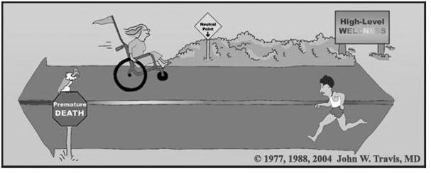

Fig. 4 The Illness-Wellness continuum as a pathway by John W. Travis

According to this model (see Fig. 4), what matters most is the direction which a person is facing, not the actual state of her physical health. One can have a high level of wellness while being on the deathbed, yet another might face premature death while not having any symptoms of disease. “A person who is physically in good health, but always complaining or worrying may be on the right of the neutral point, but definitely facing the left – toward premature death. Conversely, another person, whose body is handicapped physically or mentally, can still have a genuinely positive outlook, be cultivating love instead of fear and consequently, be facing to the right, in the direction of high-level wellness” [16, p. xx]. This model is an acknowledgement of the whole-person, holistic approach to health and well-being.

Multi-dimensional wellness
Despite some common bodily associations with wellness such as balanced nutrition or fitness, wellness is “a process of becoming aware of and making choices toward a more successful existence” [The National Wellness Institute, as cited in 3, p. 13], whereas this successful existence is based on “the experience of living life with high levels of awareness, conscious choice, self-acceptance, interconnectedness, love, meaning and purpose. Wellness is the individual’s life journey (and our society’s at large) of taking Abraham Maslow’s concept of self-actualization and applying it to mind, body, spirit and our interconnectedness with other people and our environment.” [3, p. 14]. In short, wellness is “everything about living well in a very conscious way” [11, p. 23] or as another wellness pioneer Donald B. Ardell puts it in his newest book it is “a lifestyle founded on personal responsibility for your own well-being” [2, p. 3]. Wellness is therefore this inside-out approach which leads toward well-being defined as “the combination of our love for what we do each day, the quality of our relationships, the security of our finances, the vibrancy of our physical health, and the pride we take in what we have contributed to our communities. (…) it’s about how these five elements interact.” [13, p. 4]. Travis’ model of wellness goes even further in its balanced approach to different areas of life since it distinguishes twelve dimensions of wellness (see Fig. 5). These dimensions include: self-responsibility and love, breathing, sensing, eating, moving, feeling, thinking, playing and working, communicating, intimacy, finding meaning and transcending [16, p. xxxi]. In his acclaimed “Wellness Workbook”, the author elaborated a self-assessment tool for self-reflection and raising of self-awareness. This tool plays nowadays a supportive role in wellness coaching processes making the journey toward wellness easier and more comprehensive for so many people.

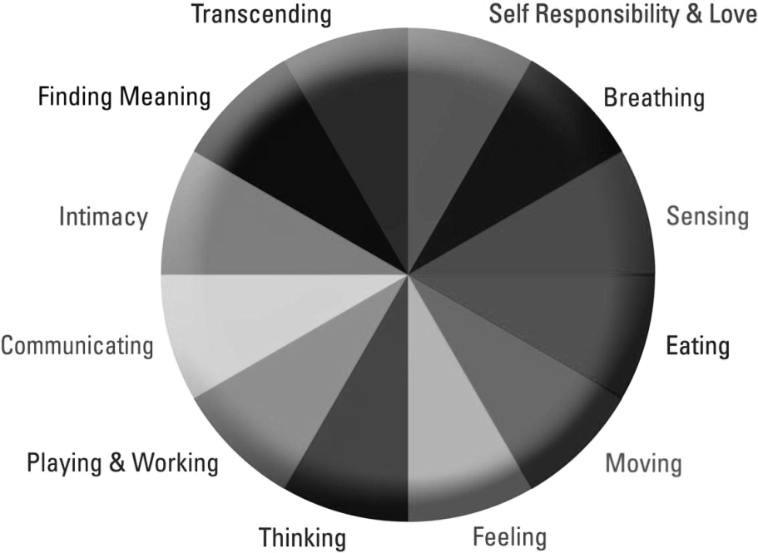

© 2002 John W. Travis and HealthWorld Online

Fig. 5 The Wellness Wheel

Evolutionary vision for medicine, health and wellness
The evolutionary vision for medicine is a developmental vision derived from an integral consciousness which holds space for using various methods in an integrative way. These methods may vary according to the depth of their action from acting solely on the body in traditional, western medicine to acting on body-mind-spirit in whole-person approaches such as wellness coaching. The evolutionary vision for medicine is humanist in nature, since it places the human being at the very center of the model. As Hippocrates, the father of Western medicine put it “it is more important to know what sort of person has a disease, than to know what sort of disease a person has” [17]. The future of medicine emerges from the paradigm of creating wellness, but remains inclusive of the old treatment-prevention-illness paradigm and uses both paradigms in a complementary way. The evolutionary vision for medicine is illustrated in Fig. 6.

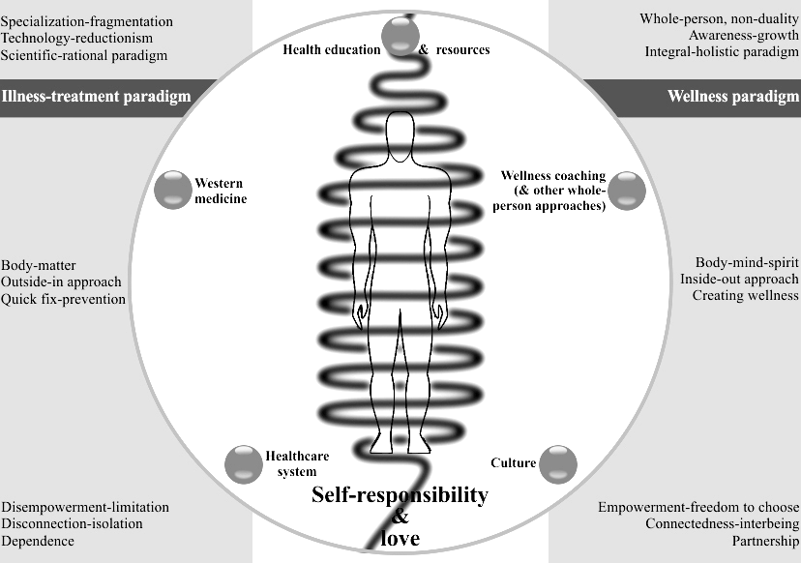

Fig. 6 The Cocoon model of integral health and well-being developed by Ewa Stelmasiak

The foundation for high-wellness conscious living are self-responsibility and love which form a cocoon around the evolutionary person (see Fig. 6). This very first dimension of wellness creates the ground for personal thriving. The Cocoon of self-care and self-acceptance is an emanation of the person’s deepest essence, it embraces her life and cradles her being, as well as her relationships with self, others and the world. The quality of this cocoon is correlated with the quality of health behaviors. The Cocoon of self-responsibility and love is the place, the deeper center from which health related behaviors emerge.
Despite the fact that the evolutionary patient has a co-dependent relationship with culture and definitely depends on the quality of the healthcare system, she is an empowered, self-responsible and self-caring individual who makes conscious choices as to living her life well. She fully acknowledges the wholeness of body-mind-spirit and understands the relationships between these spheres of being. Moreover she recognizes the various approaches and therapies and values them for what they are while using them in an integrative way. Turning to western medicine is for her just one of the options and she fully acknowledges its strengths and limitations. Simultaneously she uses whole-person approaches for self-development and growth in the long-term, and gets acquainted with resources that educate her and grow her knowledge about health. The evolutionary patient looks in the direction of wellness, even if health issues arise. Thanks to her awareness of self, as well as health issues, she is rarely called to turn to western medicine, she nevertheless fully acknowledges its science-based possibilities and feels secure with having access to some of these immediate fixes. In addition, she takes into account all dimensions of wellness and makes conscious efforts in order to live a balanced life. For this to happen, she may choose to turn to wellness coaching since she acknowledges it is a whole-person, comprehensive, empowering, awareness-building process which provides her the much needed support in her journey toward wellness.

Conclusions
In this article we have defined health and disease and advocated for whole-person approaches to health and well-being including wellness coaching as a powerful, comprehensive, wellness-oriented tool for growth. We have also proposed “The Cocoon model of integral health and well-being” which is an illustration of the integral, evolutionary healing at the center of which stands the evolutionary person who values freedom of making conscious choices relative to her health. At this point we would like to emphasize three fundamental recommendations which emerge from the unfolding of our vision.
First of all, the world is in constant evolution, so is human consciousness and so are outside, objective realities such as structures and systems which reflect this consciousness. In this light thinking about the healthcare system or culture in a self-responsible way would require from us asking ourselves what could be our contribution to this current state, or what is the state of consciousness of the people we are choosing to make decisions which impact our lives. At the same time it is necessary to look deeply into ourselves to become living examples of the whole-person approach to life. The first conclusion is therefore an encouragement for evolutionary patients to cultivate awareness, because awareness has the power to lead us to a state of health and well-being. Secondly, whenever illness occurs, it can be used as a “reminding bell” that some underwater parts of the being have probably been neglected. Let disease become this action-button for bringing the light of awareness to underwater layers of the iceberg and looking deeper through the prism of the twelve dimensions of wellness. On the other hand if no disease occurs, it is recommended to allow the “dive into your whole being” approach emerge from the cocoon of self-responsibility and love and follow it wholeheartedly. Our third recommendation is to cultivate self-responsibility and love on an ongoing basis since it lays the foundation for all life choices, including those related to health and well-being. All these are topics to be looked deeply into in the process of wellness coaching.
Last not least, we would like to emphasize that our vision for medicine is integral which means that we assume that the various complementary practices and methods, as well as both the illness-treatment and wellness paradigms are aligned toward the same goal of wellness, healing and growth of humanity. This view outgrows a worldview where there is space for tolerant co-existence of many competing fields without referring to their greater, overarching sense, and it certainly outgrows the pure pluralistic worldview based on individualism and relativism. As humanity we are on our way to wellness on both micro, macro and planetary levels. Just as atoms are part of molecules and molecules are part of cells, all of our human steps are part of some kind of greater, evolutionary pattern. To put it in the right perspective, the field of medicine is just a manifestation of this evolutionary pattern, in the very same way as is the individual or collective consciousness of patients, doctors, coaches and healers. Allowing ourselves to align with this very goodness of life has the power to make wellness a realistic objective on any of these levels and thus contribute to the evolving and well-being of humanity as a whole.

List of works cited
- Alexander, L.: How to incorporate wellness coaching into your therapeutic practice. Singing Dragon, London & Philadelphia, 2011.
- Ardell, D.: Real Wellness. CreateSpace Independent Publishing Platform, 2010.
- Arloski, M.: Wellness Coaching for Lasting Lifestyle Change. Whole Person Associates, Duluth, MN 2009.
- Brock, V.: Sourcebook of coaching history. Amazon.co.uk, Ltd., Marston Gate 2012.
- Chopra, D. & Mlodinow, L.: War of the worldviews. Science vs. spirituality. Harmony Books, New York 2011.
- Damasio, A.R.: Descartes’ Error. Emotion, Reason and the Human Brain. Quill, New York 2000.
- Dunn, H.L.: High-Level Wellness. Beatty Press, Arlington, VA 1961.
- International Coaching Federation, retrieved from http://www.coachfederation.org/ on February 27th, 2013
- Kabat-Zinn, J.: Full catastrophe living. How to cope with stress, pain and illness using mindfulness meditation. Piatkus, New York 2011.
- Kimsey-House, H. at all.: Co-active coaching. Changing Business, Transforming Lives. Nicholas Brealey Publishing, Boston & London 2011.
- Moss, L.E.: Body-mind life coaching: using the body to deepen awareness and forward the action. Course Manual, Institute for Life Coach Training 2011.
- Pilzer, P.Z.: The wellness revolution. How to Make a Fortune in the Next Trillion Dollar Industry. John Wiley & Sons, Inc., Hoboken, NJ 2007.
- Rath, T. & Harter, J.: Well-being. The Five Essential Elements. Gallup Press, New York 2010.
- Rogers, J.: Coaching. Podstawy umiejętności. Gdańskie Wydawnictwo Psychologiczne, Gdańsk 2010. Originally published as: Coaching Skills. A Handbook. Open University Press, 2008.
- Snyderman, R. & Weil, A.T.: Integrative medicine: Bringing medicine back to its roots. Archives of Internal Medicine 162, 4.
- Travis, J. & Ryan, R.: Wellness Workbook: How to Achieve Enduring Health and Vitality. Celestial Arts, Berkeley 2004.
- Wellness Inventory Certification Training course materials, more information available at www.wellpeople.com, 2013.
- Wilber, K.: A theory of everything. An integral vision for business, politics, science and spirituality. Shambhala, Boston 2001.
- Wilber, K.: The integral vision. Shambhala, Boston & London 2007.

Abstract
The author defines health as emergent of a whole-person, integral worldview and places medicine inside of an evolutionary perspective where the wellness and illness paradigms are aligned toward the common goal of wellness, healing and growth of humanity. Moreover, she proposes a new model of integral health and well-being based on the assumption that self-responsibility and love serve as cocoon which is the birthplace for health and wellness-oriented behaviors. Evolving beyond the reign of the rational, science-based paradigm, the evolutionary patient fully acknowledges the benefits of wellness coaching as an empowering and awareness-building tool in her journey toward wellness.

Streszczenie
Autorka definiuje zdrowie w świetle holistycznego, integralnego światopoglądu, medycynę zaś umiejscawia w perspektywie ewolucyjnej, w ramach której zarówno paradygmat choroby-leczenia, jak i paradygmat dobrostanu wpisują się w ewolucyjne dążenie ludzkości do rozwoju. Autorka proponuje ponadto nowy model integralnego zdrowia i dobrostanu, który opiera się na założeniu, że branie odpowiedzialności i troska o siebie są swoistym kokonem, który pomaga narodzić się zachowaniom prozdrowotnym i nakierowanym na dobrostan. Wznosząc się ponad dyktat racjonalnego, naukowego paradygmatu, ewolucyjny pacjent w pełni docenia korzyści wynikające z wellness coachingu jako procesu, który buduje świadomość i stanowi wsparcie na drodze do dobrostanu.

Artykuł zawiera 29417 znaków ze spacjami + grafika

